Experiment No 1

Title:
Understanding the fundamentals of UI design for the GrocerySpot mobile application.

Objective:
To understand and implement the fundamentals of UI design for the GrocerySpot mobile application, ensuring a user-friendly and visually appealing experience.

Theory:

Introduction to mobile UI design principles and guidelines:
Mobile UI design principles and guidelines are crucial for creating an intuitive and engaging experience for users. Here are some key principles and guidelines for the GrocerySpot app:
1)Clarity and Simplicity:
Keeping the interface simple and easy to navigate.
Avoiding clutter by prioritizing essential information and features.
Using clear and concise language for labels and instructions.

2)Consistency:
Maintaining a consistent design throughout the app.
Using consistent navigation patterns, colors, and typography.
Following platform-specific design guidelines.
Providing clear and immediate feedback for user actions.
Use animations or micro-interactions to indicate system responses.
Display relevant feedback messages for actions like successful login or order placement.

4)Navigation:
Creating a clear and intuitive navigation structure.
Using familiar navigation patterns such as tabs or bottom navigation.
Ensuring users can easily find products, categories, and their shopping cart.

5)Typography:
Choosing legible fonts that enhance readability.
Maintaining a consistent typographic hierarchy for headers, subheadings, and body text.
Considering font size and spacing for optimal readability on mobile devices.

6)Color Scheme:
Using a cohesive color palette that aligns with your brand and enhances the user experience.
Ensuring sufficient contrast between text and background colors for readability.
Considering color psychology to evoke desired emotions or actions from users.

Analyzing popular grocery apps to identify common UI elements:
Some popular grocery apps include Instacart, Walmart Grocery, and Amazon Fresh. These apps feature several common design elements that enhance the user experience:

Product Listings: Products are displayed in a list or grid view, prices, and quantity.
Filter and Sort Options: Users can refine search results based on various criteria such as price, brand, or dietary preferences.
Shopping Cart: A visible shopping cart icon displays the number of items added and allows users to review and edit their cart.
User Profile: Users can manage their account, view order history, and update personal information in the user profile section.

Designing a basic UI layout using wireframing tools like Figma:
Using Figma, create wireframes for the various screens of the GrocerySpot app, including the login, signup, product listings, and checkout screens. Experiment with different layouts and arrangements to find the most intuitive design for users.
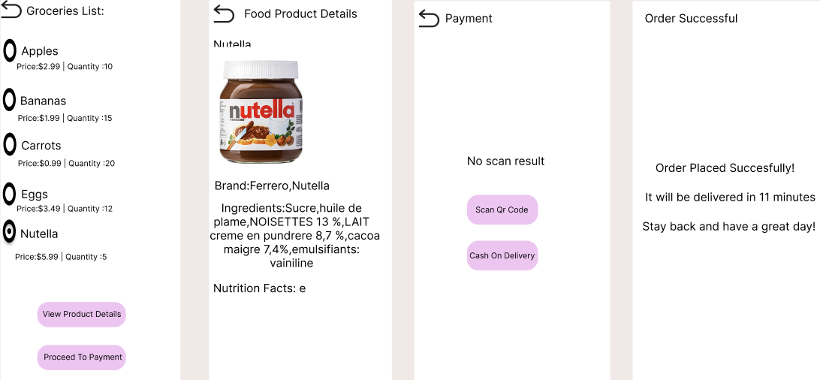

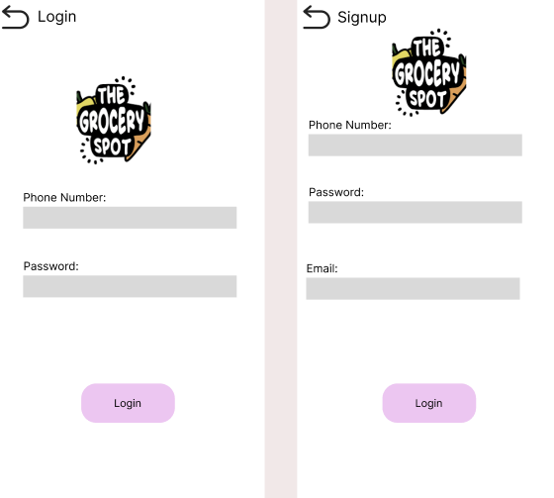

Implementing basic UI elements such as buttons, text fields, and labels:
Ensure that buttons are easily clickable and clearly labeled, text fields are adequately sized for input, and labels provide context for each UI element.
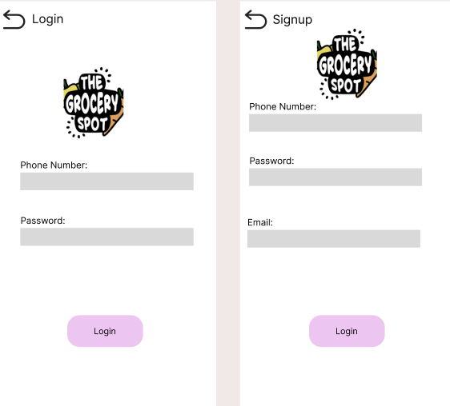

Experiment with different layout options and color schemes:
Test different layout options to find the most user-friendly design for the GrocerySpot app. Experiment with color schemes to create a visually appealing and cohesive look.
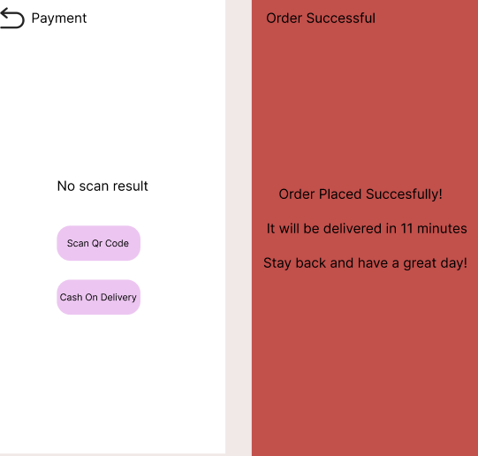

Testing the UI design on a mobile device or emulator for usability and responsiveness:
Prototype the UI design and test it on a mobile device or emulator to ensure that it is responsive and user-friendly. Check for any usability issues and make adjustments as needed.
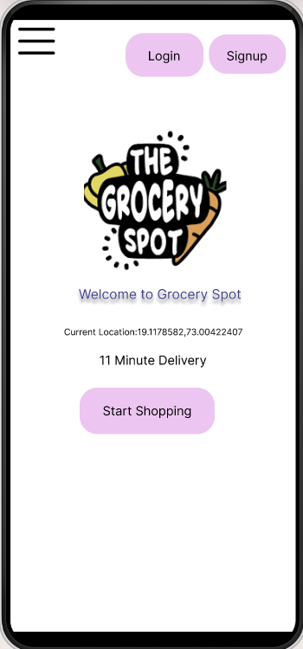

Conclusion:

By understanding and implementing the fundamentals of UI design for the GrocerySpot app, we can create a visually appealing and user-friendly experience for our users. Through experimentation and testing, we can refine our design to ensure that it meets the needs and expectations of our users, ultimately leading to a successful and engaging app.

